**For Property Object**

Create the remaining Fields:

Follow the above activity 1 Steps 1 to 2 , create the Field just change the Labels and data types for Below Fields

1. **Customer name** (lookup relationship related to Enquiry)

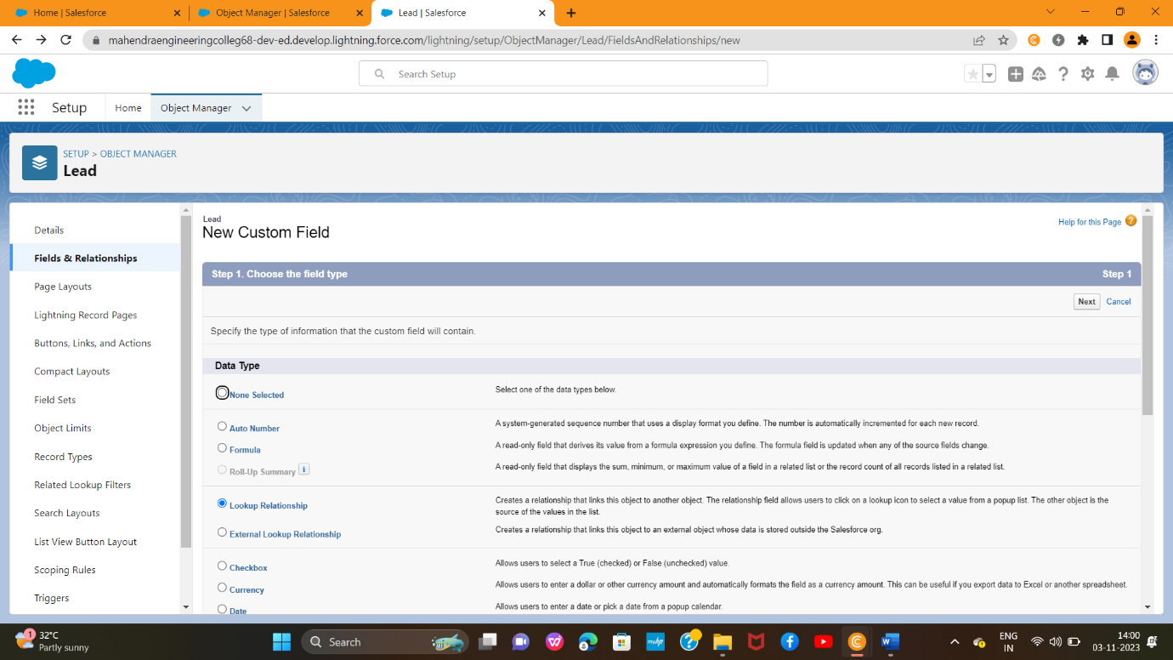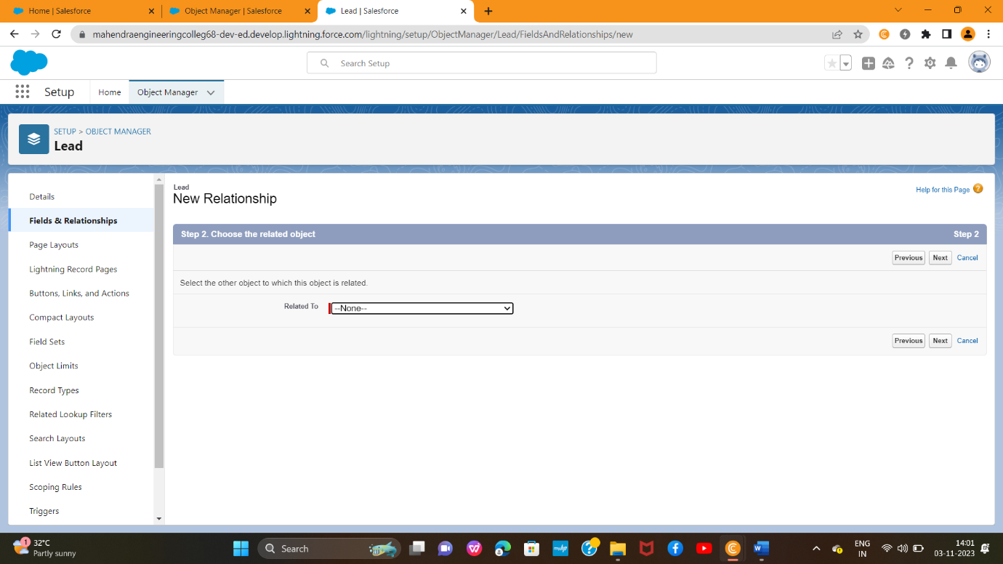

1. **Create Property Type**: (Picklist fields) (Residential, Commercial, Industrial) (Field Dependency)

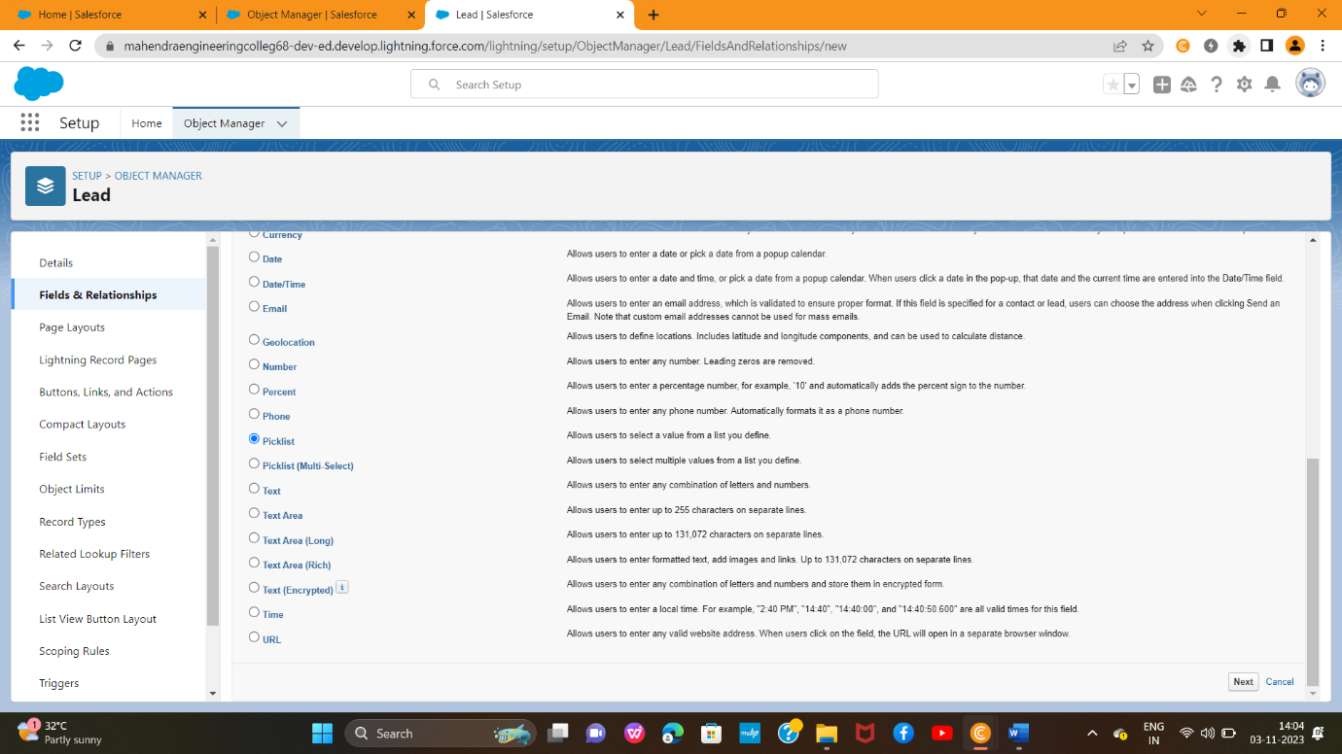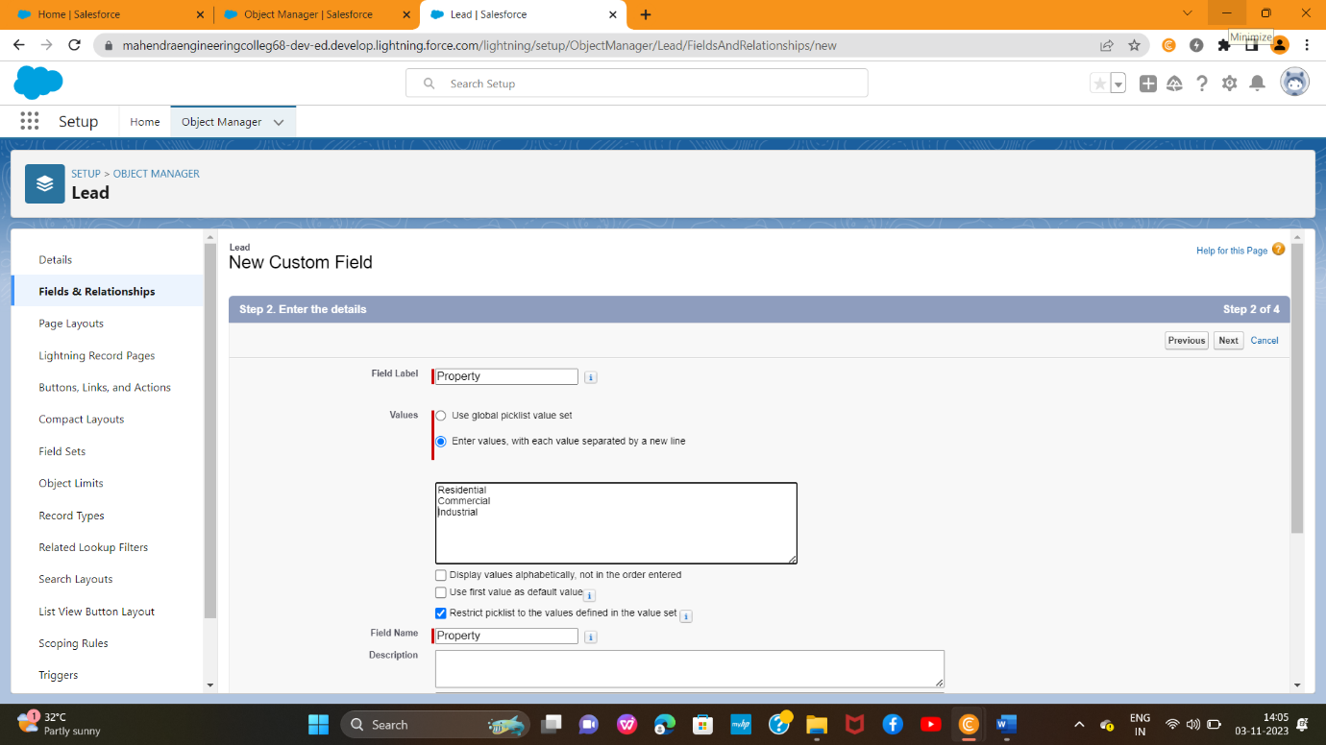

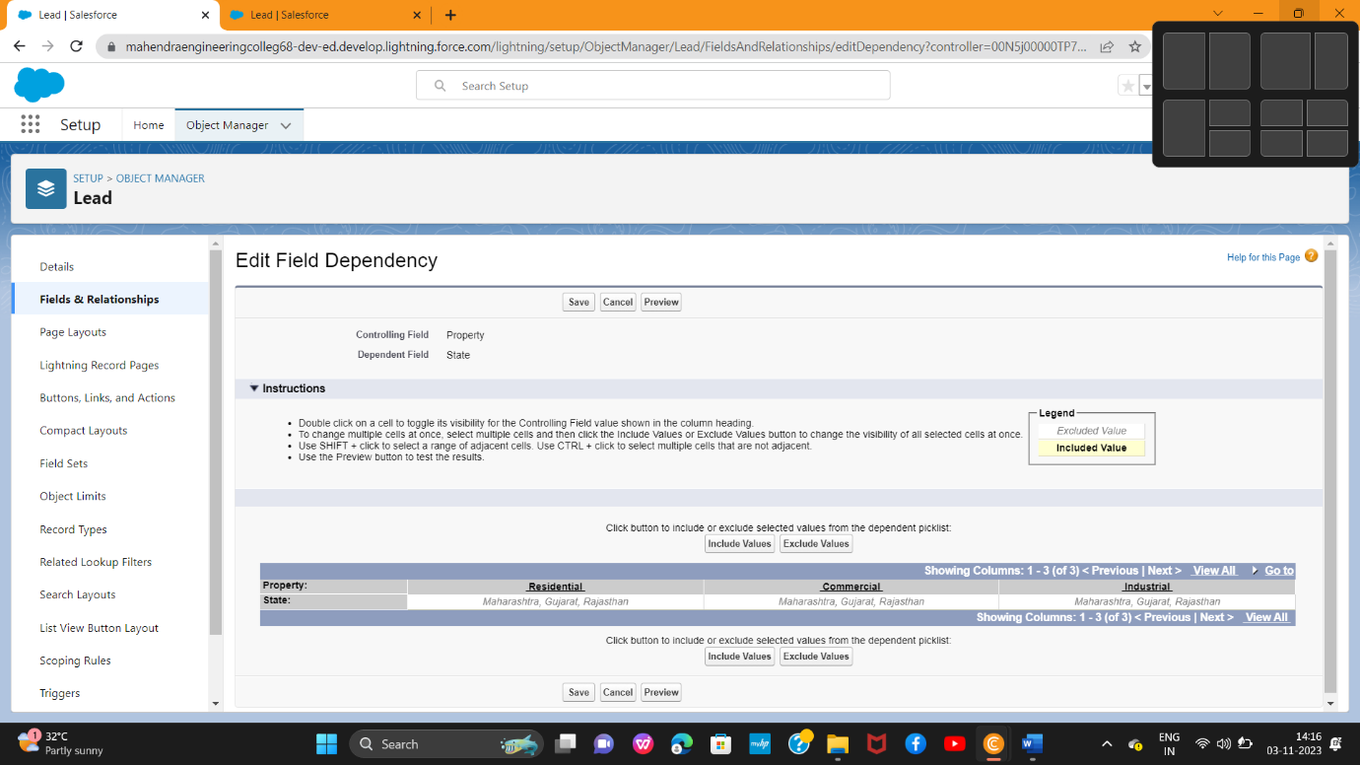

1. **Residential: Picklist fields**(1BHK, 2BHK,3BHK) (Field Dependency)

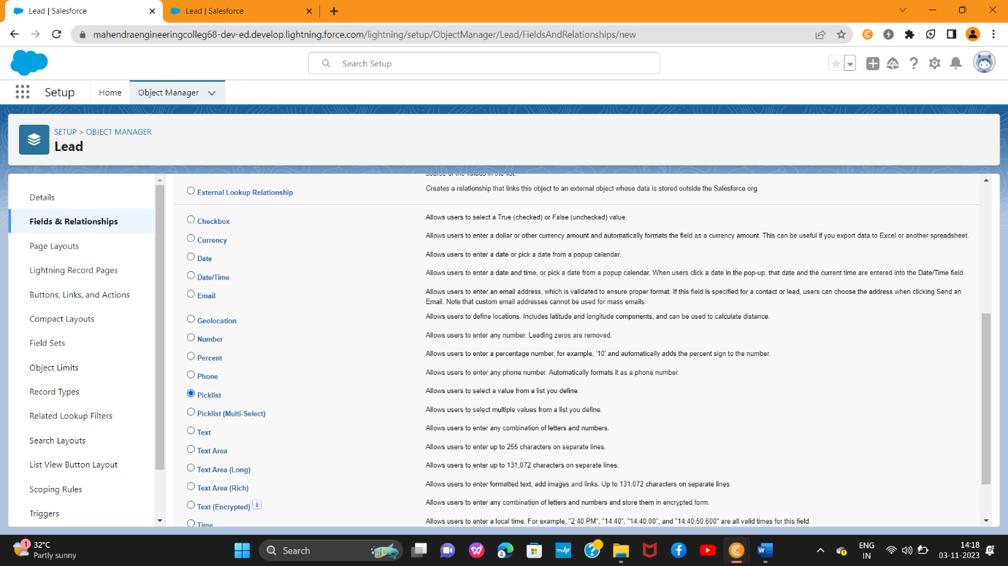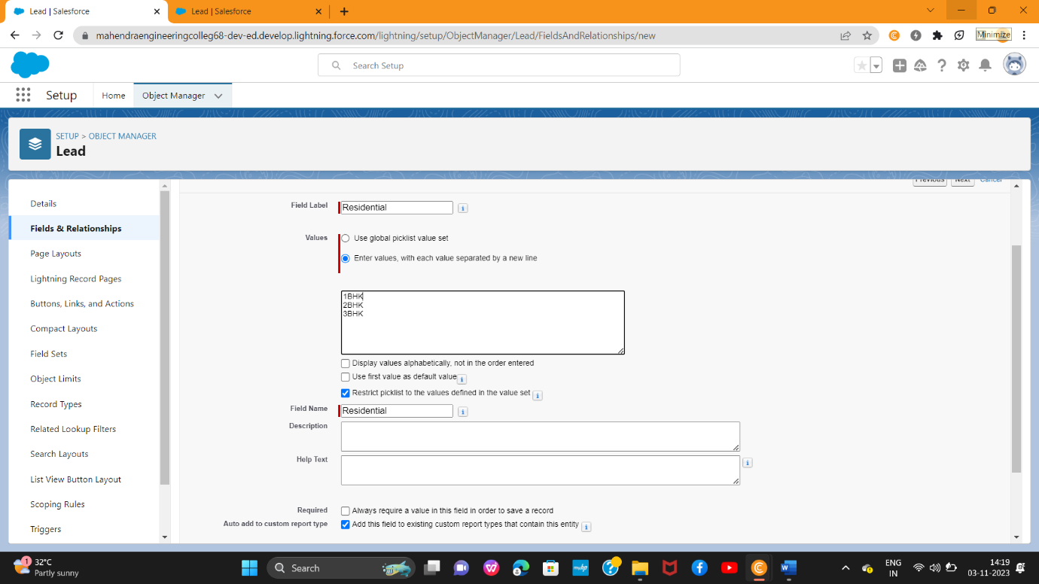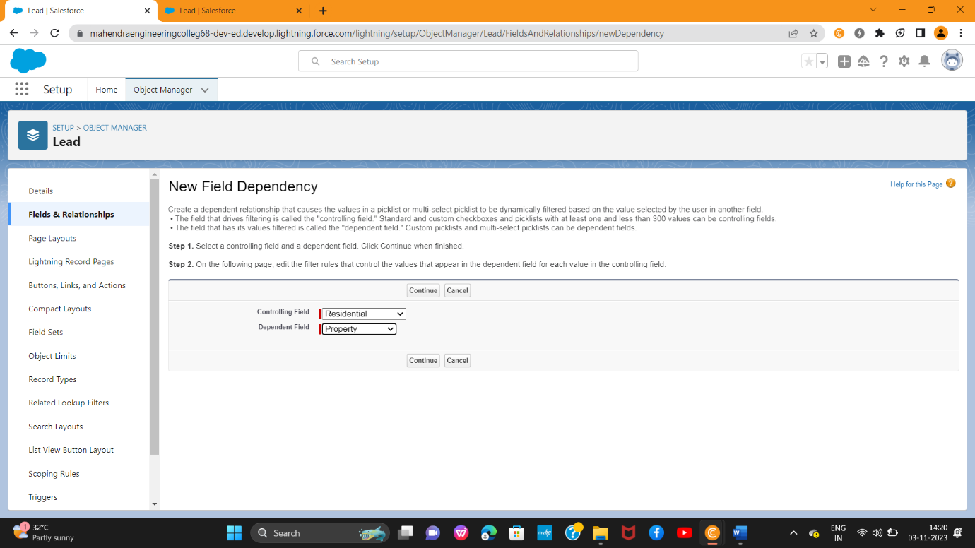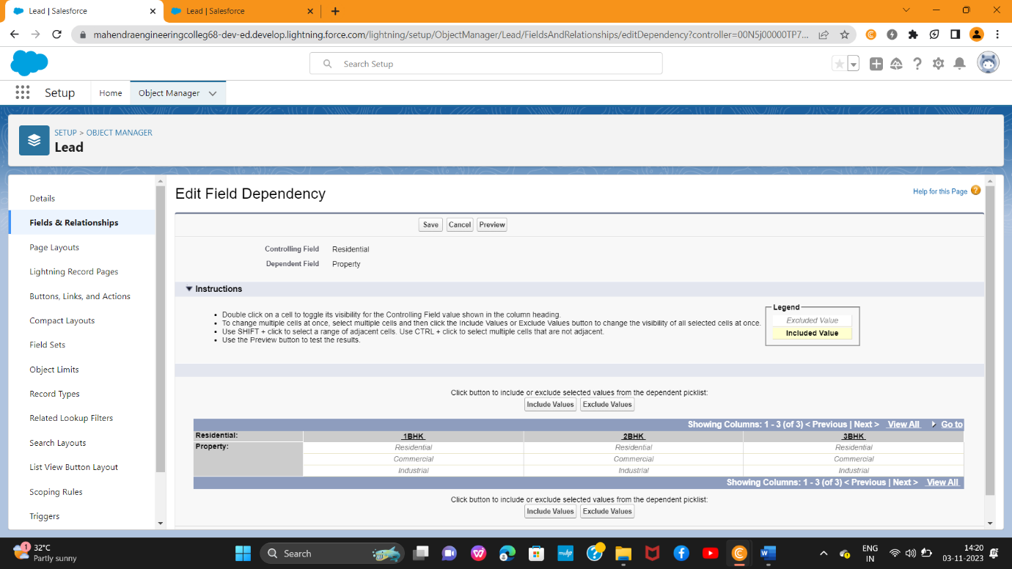

1. **Commercial**: Picklist fields (Shop, Office) (Field Dependency)

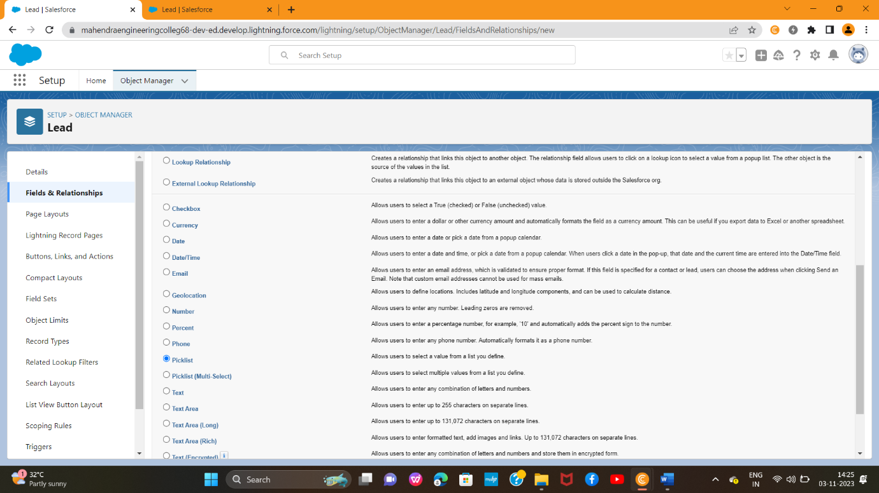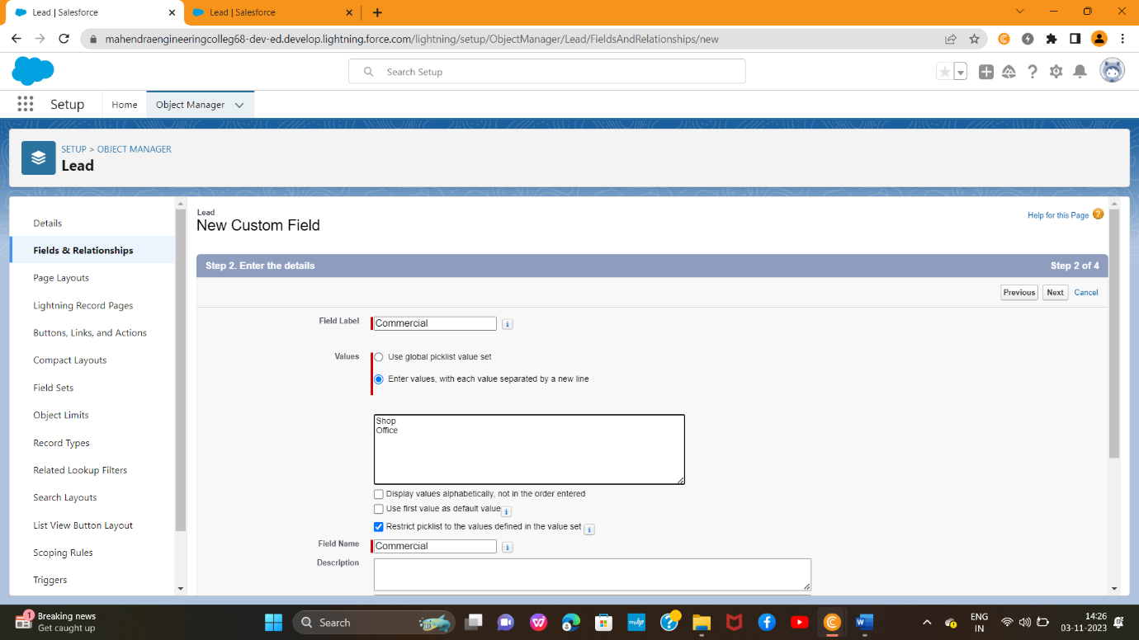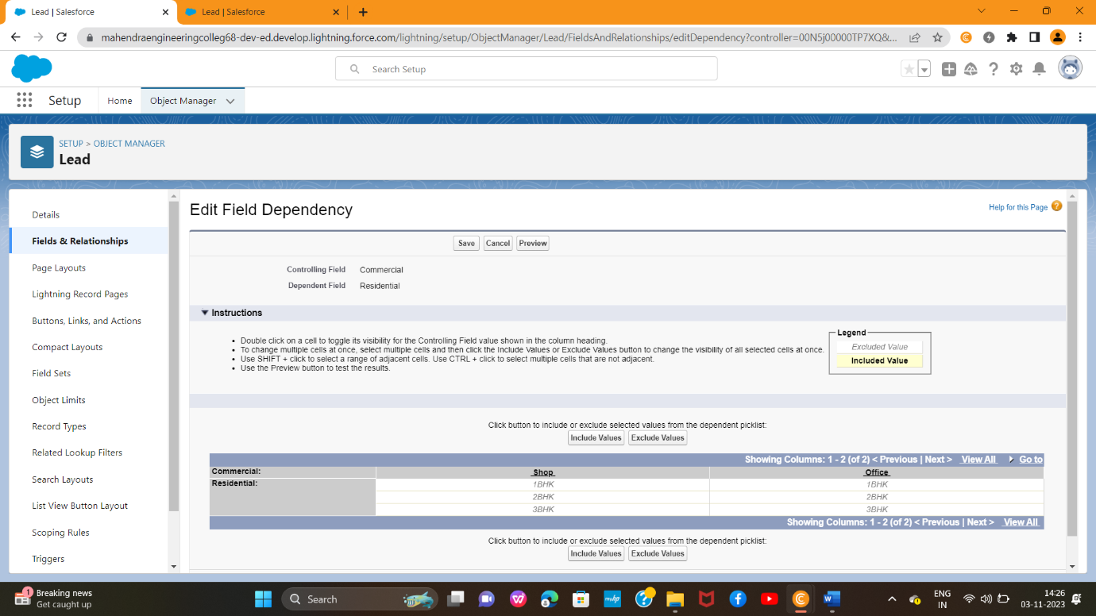

1. **Industrial:** Picklist fields (Factory, Mall) (Field Dependency)

**Note**: In above picklist fields Property type is control field and Residential, Commercial, Industrial is dependent field.

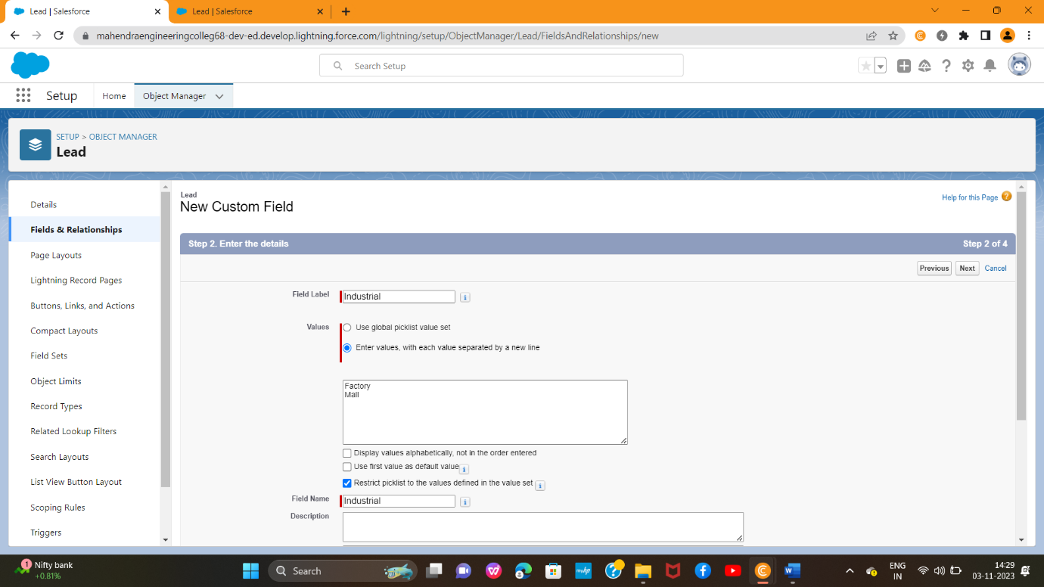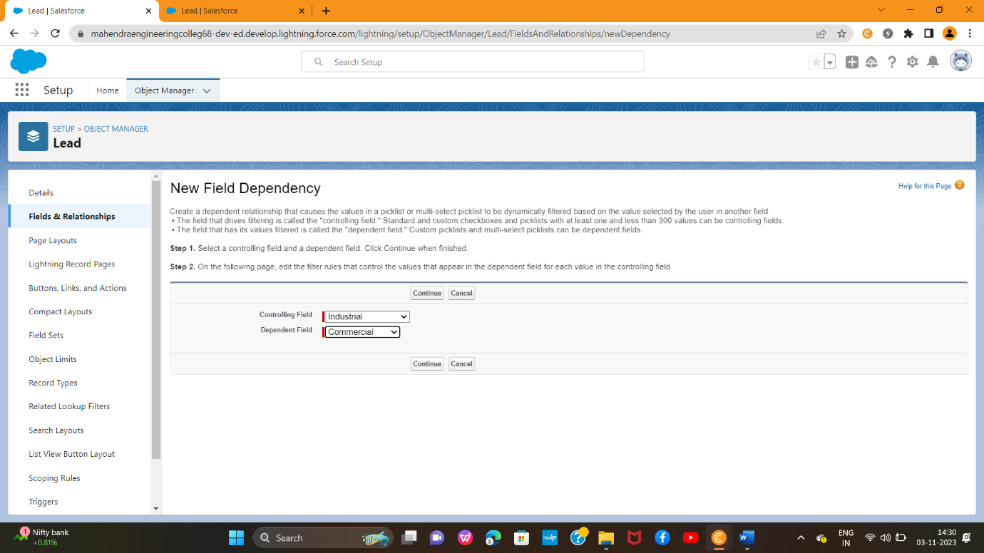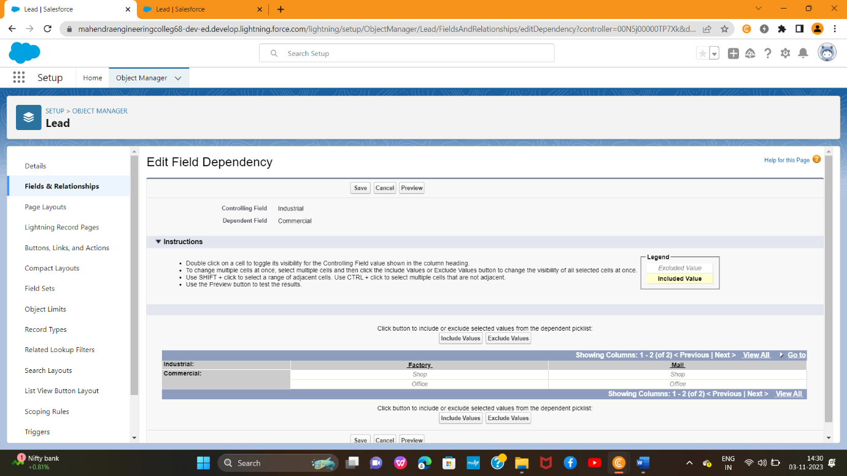

1. **State**: Create the Picklist Field (Maharashtra, Gujarat, Rajasthan)(Field Dependency)

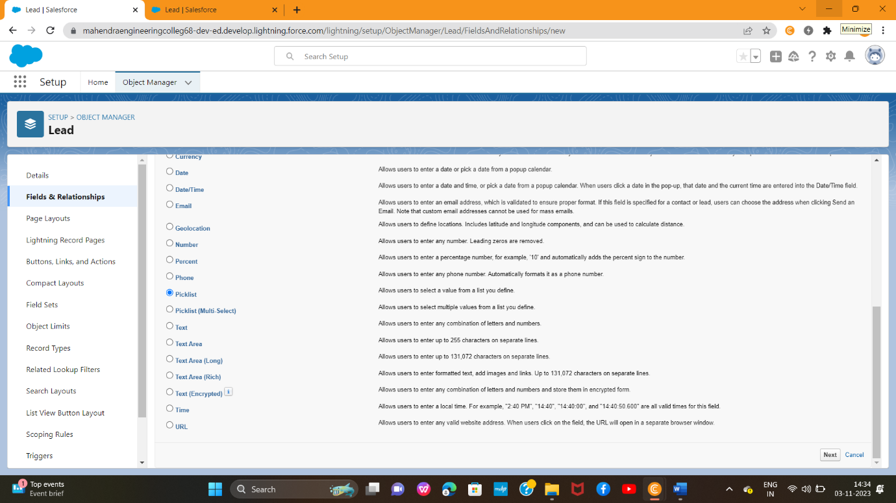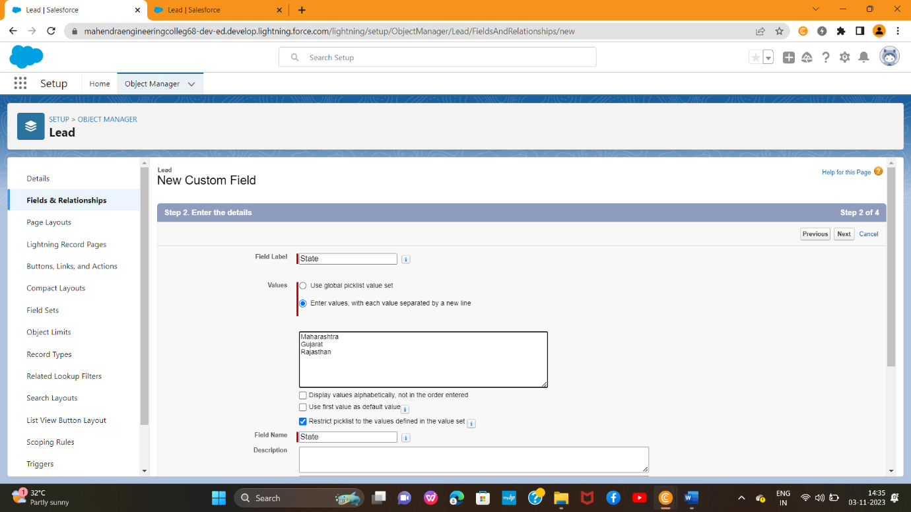

**7. City:**(Take Any City for Field Dependency)

Note: In above picklist fields State is a control fields and city is dependent field

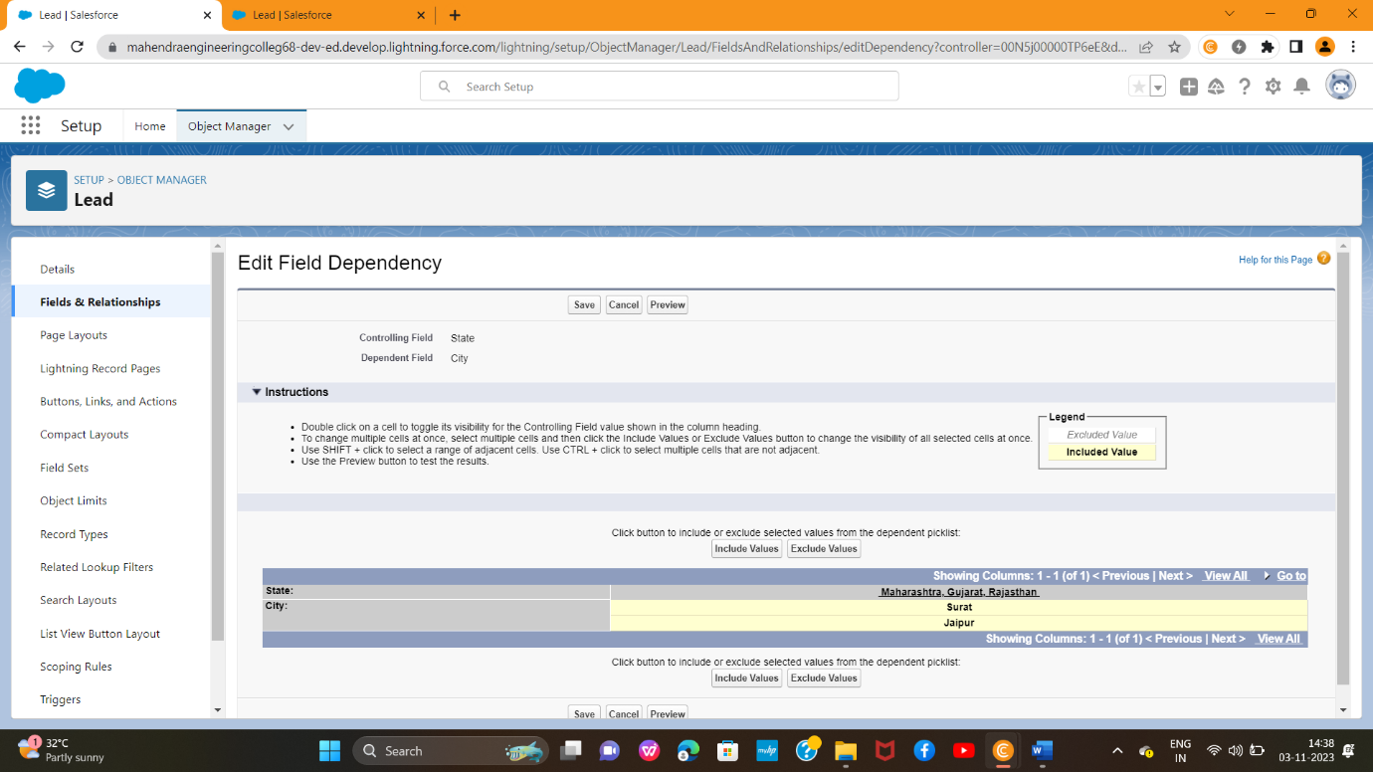

1. **Discount:**(Percentage As the Field Data Type)

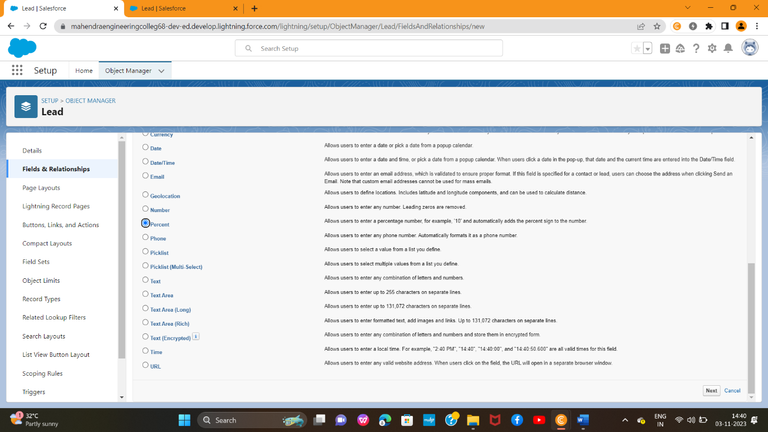

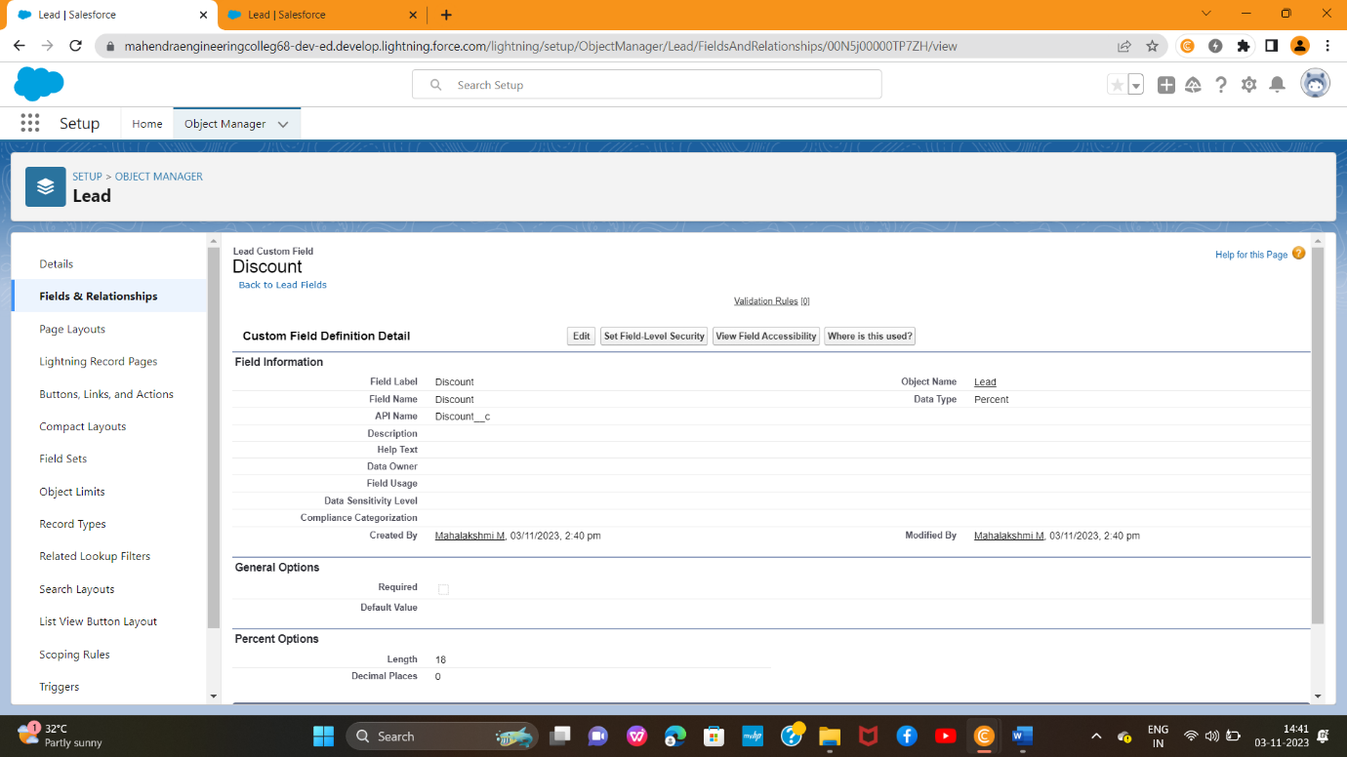

1. **Price:** (Number As the Field Data Type)

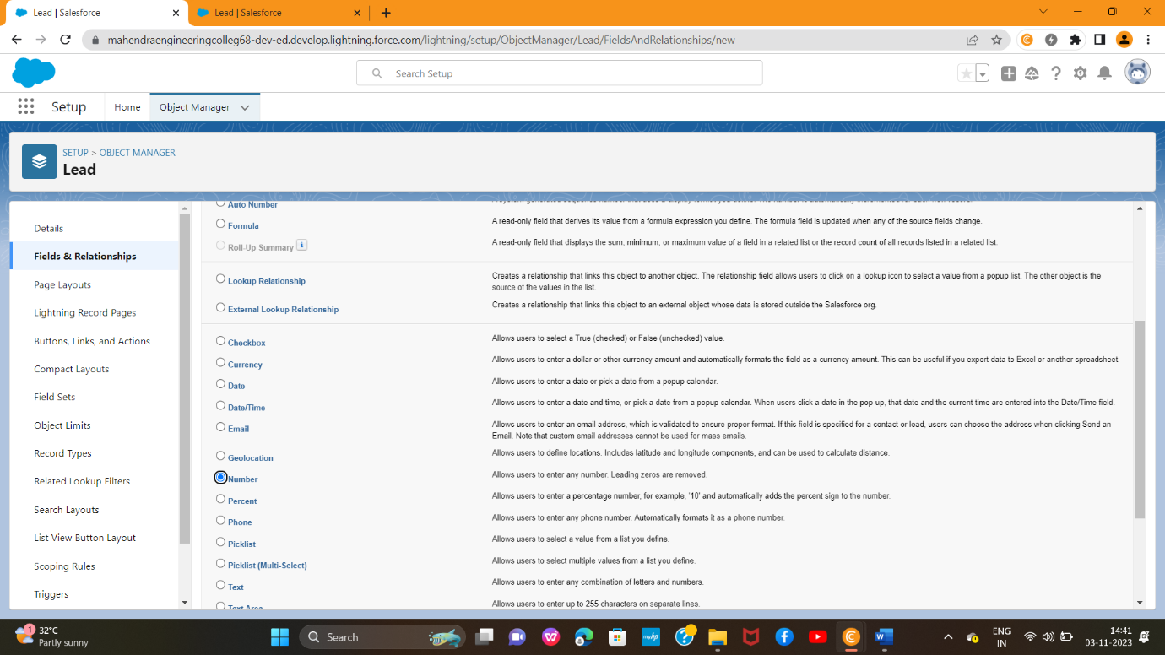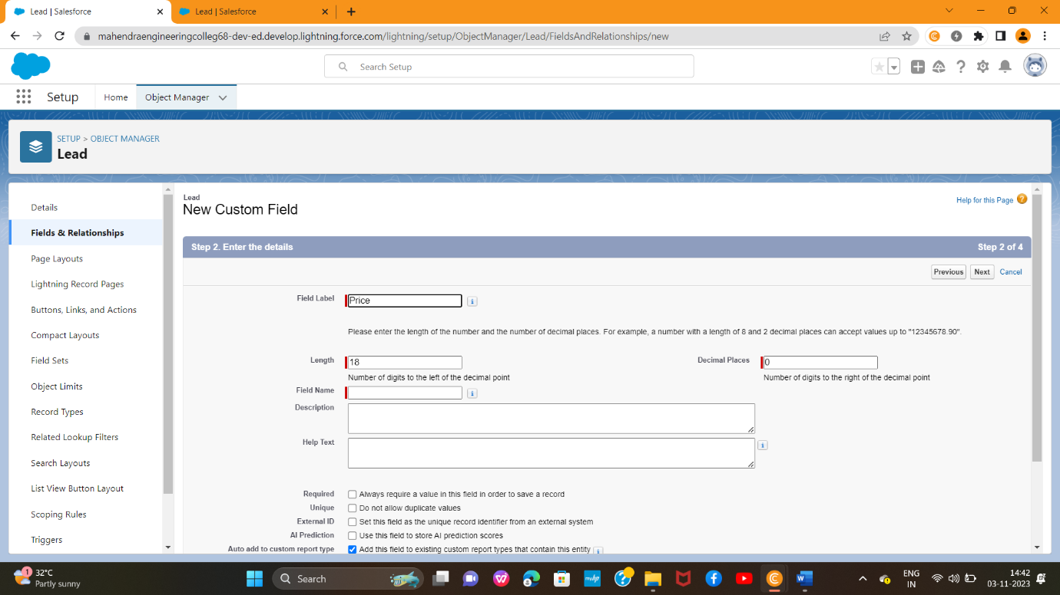

1. **Loan Amount:**(Currency As the Field Data Type)

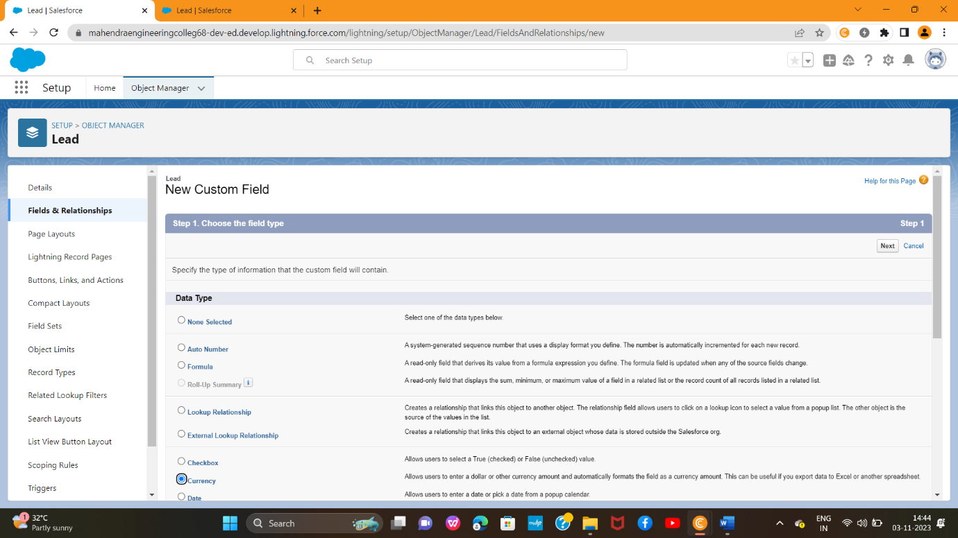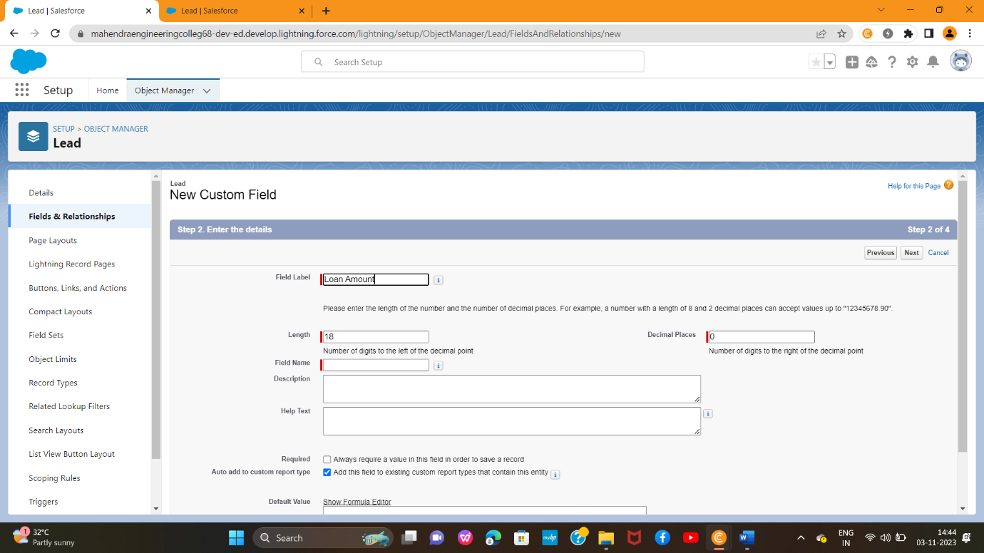

**For the Property Object >>**Go to the fields and Relationship and select the formula in field data type. In  
Formula option select Advanced Formula and write the following formula.

Enquiry**_Id__r.Customer_Name__c**

